REQUIREMENT ANALYSIS
Data flow diagram and user stories:
Dataflow diagram
A dataflow diagram (DFD) is a traditional visual representation of the information flows within a system. A neat and clear DFD can depict the right amount of the system requirement graphically. It shows how data enters and leaves the system , what changes the information and where data is stored.
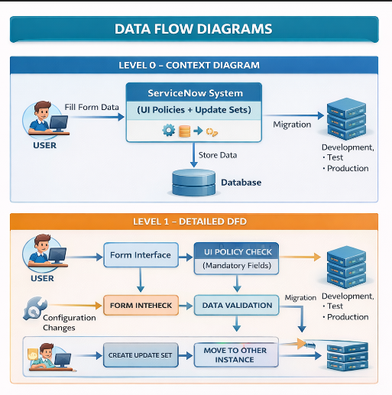

User stories
Users stories defines what different users need from the system in simple, goal-focused language. In this project , they help ensure the system blocks user deflection only when necessary ,protecting incident data.

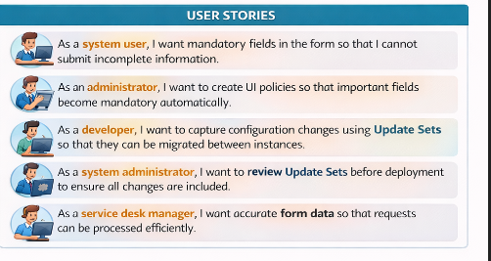

Solution Requirement:
Functional requirements
ID | FUNCTIONAL REQUIREMENTS
FR1 | The system should allow users to fill and submit forms.
FR2 | The system should enforce mandatory fields using UI Policies.
FR3 | The system should prevent form submission if required fields are empty.
FR4 | The system should display validation messages for missing fields.
FR5 | The administrator should be able to create and manage UI policies.
FR6 | The system should capture configuration changes using Update Sets.
FR7 | The system should allow migration of update sets between instances.

Non-functional requirements
ID | NON-FUNCTIONAL REQUIREMENTS
NFR1 | The system should provide quick response time when loading forms.
NFR2 | The system should ensure data accuracy and integrity.
NFR3 | The system should provide secure access to administrators and users.
NFR4 | The system should be reliable and available for users.
NFR5 | The system should support easy maintenance and configuration updates.
NFR6 | The system should handle multiple users simultaneously.
NFR7 | The system should ensure safe migration of configurations between instances.

